Court File: T-1450-15

FEDERAL COURT OF CANADA

BETWEEN:

Radu Hociung

Plaintiff

and

Minister of Public Safety and Emergency Preparedness
and
Canada Border Services Agency
and
Her Majesty the Queen in Right of Canada

Defendants

LETTER TO THE COURT
Re: Reply to Defendant's Further Additional Reponse

Radu Hociung
246 Southwood Drive
Kitchener, Ontario
N2E 2B1
Tel: (519) 883-8454
Fax: (226) 336-8327
email: radu.cbsa@ohmi.org

TO:
The Registrar
Federal Court of Canada
180 Queen Street West
Suite 200
Toronto, Ontario
M5V 3L6

AND TO (by email):
Derek Edwards, Counsel to the Defendant
DEPARTMENT OF JUSTICE
Ontario Regional Office
120 Adelaide Street West
Suite 400
Toronto, Ontario
Tel: (647) 256-7493
Fax: (416) 973-5004
June 24, 2020

Mr. Justice Gleeson,

In REPLY to the Defendant's responding submissions dated June 22, 2020, the Plaintiff makes the following submissions.
In addition to disputing some representations, the Defendant (the Minister of Public Safety and Emergency Preparedness), makes several submissions in defence of the individuals charged with fraud and threats of violence. The party with respect to whom these claims are made is Her Majesty (by vicarious/direct liability), and the Minister has no standing to make representations on Her Majesty's behalf. All these submissions must therefore be struck, for lack of standing.

Undisputed representations

- The Defendant does not dispute that the claims relating to threats of violence cannot be dismissed.
- The Defendant does not dispute that he has admitted that there is no evidence that the coins are “goods”. (The Plaintiff requests a Direction as to whether the Record of the Federal Court of Appeal is in acceptable form to be considered by this Court, ie, whether this Court requires the Registrar to transcribe the audio recording of the hearing, or the audio recording is sufficient)
- The Defendant does not dispute that the summary motion is an “all or nothing” request, ie, either the Court must grant the motion and “dismiss the action in its entirety” or dismiss the motion; no alternative approach is possible, on this motion, as brought, whereby only part of the claims are determined and dismissed. The defendant in fact acknowledges the “all or nothing” nature of his motion, by reiterates the defence of Customs Act section 106 for all claims but judicial review claim; this is the same defence he made in the motion record.
- The Defendant does not dispute that the section 135 claim is a request for judicial review of the Minister's Decision.
- The Defendant does not dispute that the standard of review for the Minister's Decision is the reasonableness standard; in short, the Decision must exhibit the “existence of justification, transparency and intelligibility within the decision making process”, or, as per Vavilov, that it be “justified, justifiable and transparent”.
- The Defendant does not dispute that the Croft jurisprudence is applicable in determining what, if any limitation of liability is available to the individuals charged with fraud and threats of violence. This is moot, as the Defendant (Minister) lacks standing to make any representations on behalf of servants of Her Majesty.

Disputed representations

- The Defendant disputes that a Federal Court of Appeal judgment is non-binding.
  - He quotes section 52(b)(iii) of the Federal Courts Act, which states that the “Federal Court of Appeal may make a declaration as to the conclusions the Federal Court should have reached...”
  - He infers that due to the declaration the Federal Court of Appeal made in this case, it has “binding jurisdiction” over the Federal Court.
  - “Binding jurisdiction” is not something that exists. I will instead assume the Defendant meant that the Federal Court is bound by the declaration made by the Federal Court of Appeal.
  - Per Oxford Dictionary, “declaration” is defined as “a formal or explicit statement or announcement”. This means the FCA stated its opinion publically, no more, no less.
  - For a “binding” to exist, two ingredients must exist: a counter-party to the bond, and a penalty for non-compliance. For example, an Order is binding by virtue of being addressed to a party, and by Rules 466(b) and 472. On the other hand, a “formal statement or announcement” is not an Order to the Federal Court, nor would the Federal Court be subject to any Penalty in case on non-compliance.
  - Section 52(b)(i) permits the Federal Court of Appeal to override the Federal Court's judgments, but this does not require the Federal Court to do anything, nor does it Penalize the Federal Court in any way. It cannot be construed to be “binding”.
  - Section 52(b)(ii) permits the Federal Court of Appeal to order a new trial. As it is an order, the Federal Court would be bound to conduct a new trial. However, it's not clear that this is what the Federal Court of Appeal did. It's judgment did not include any Order. In any case, when it does order a new trial, the Federal Court of Appeal does not have the power to require a specific outcome, nor to require that specific factual findings be made.
  - The notion that the Federal Court of Appeal can require another court to make specific factual findings is contrary to the principle of judicial independence, and is therefore a flawed interpretation of the the Federal Courts Act.
  - The Federal Court of Appeal noted in its reasons at para 60 of A-102-18 that it had not heard arguments from either side on the numerous legal issues raised, and is not in a position to make findings. What would be the meaning of “binding” on the Federal Court? The Federal Court of Appeal nonetheless provided the opinion that there is no “real, as opposed to theoretical” dispute (para 63). Is the Federal Court bound by the FCA's opinion, which was given in spite of explicitly not hearing any evidence? The plaintiff submits that the Federal Court is not “bound” by the FCA's opinions.
- The Defendant submits that since the Application for leave to appeal to the Supreme Court was dismissed, this means the Federal Court of Appeal was upheld by the Supreme Court. This is perverted logic submitted to support the incorrect notion that the Federal Court is bound by another Court's judgment. The reality is that the Federal Court of Appeal's judgment was not heard by the Supreme Court, so it was neither upheld nor quashed. The Supreme Court gave no reasons why the Application for leave was dismissed, and none can be inferred.
- Regarding the Motion to Amend, the defendant submits that all but 4 paragraphs of the Amended Statement of Claim should be struck.
  - The Defendant (Minister of Public Safety and Emergency Preparedness) lacks standing with respect to claims to which he is not a party. The Minister is only party to the claim for judicial review of his Decision, and the specific claims of relief in which the Minister is specifically named. The Minister may not make any representations regarding claims with respect to the other parties, namely, Her Majesty and the Canada Border Service Agency, which are parties distinct from the Minister.
  - The Motion to Amend is not a Motion to Strike. The claims that are already on the Statement of claim are not subject to being struck under this Motion. Only the amendments and new claims are subject to any consideration.
  - The defendant has not identified any amendments or new claims that could be struck, nor has he made any attempt of demonstrating grounds for them being struck.
  - The grounds for striking amendments are the same as for striking claims:
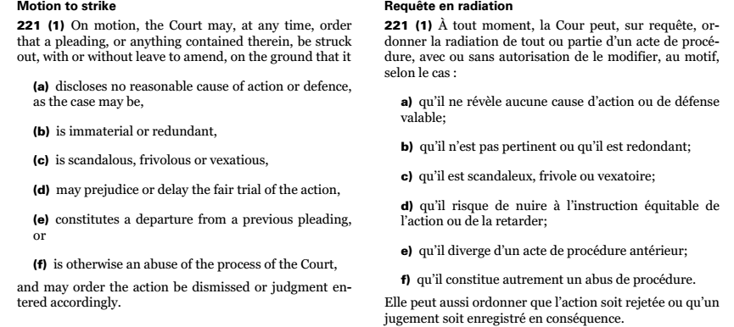
  - Expressly, whether a claim is easy or hard to prove is not a ground for striking. To be capable of being struck, a claim must be manifestly incapable of being proven, without consideration to any evidence, which is not permitted on a motion to strike, see R. v. Imperial Tobacco Canada Ltd., 2011 SCC 42 (CanLII). In other words, the claim can be struck if it would be unsuccessful even if it is true as pleaded. The pleading defect must be of irreparable, such as if the court lacks the jurisdiction to hear the matter.
  - The defendant has not demonstrated that any amendments may be struck. The existing claims are not subject to any modifications or striking.

Duress

The Plaintiff has requested Mr. Justice Gleeson to recuse himself from this proceeding on several occasions prior, and considers him an unjust, unethical, and corrupt judge. Given Mr. Justice's insistence that he is “seized” to the proceeding, that he will be the only judge involved in the proceeding until its is able to dismiss it, the Plaintiff's is effectively hostage to Mr. Justice Gleeson's will. Justice Gleeson has disregarded the Rules of the Federal Court, and although the Federal Court of Appeal made it clear that he does not have such a power, he continues to disregard all Rules. At present time, Justice Gleeson is acting as if he were Case Management Judge, although he was not appointed as such. When the Plaintiff addressed him as “Mr. Gleeson” at a “case management teleconference”, on the ground that he is not properly the Court, since he was not dully appointed Case Management Judge, Justice Gleeson threatened the plaintiff with consequences for “disrespect”.
The Plaintiff feels as a unwilling victim of an intellectual rapist, being forced to show “respect” to his oppressor, and is unable to make the coherent, well reasoned arguments he would make before an impartial judge. As the Justice follows rules known only to him, rather than the Federal Court Rules, the plaintiff is prevented from knowing what criteria his submissions will be evaluated by, and is prevented from researching jurisprudence in order to make the best case possible. The plaintiff is limited to throwing darts in the dark.
Given that the Justice has so far disregarded the Rules of the Court, and continues to do so, and given that as explained above, the Plaintiff believes no additional representations were necesssary at all, in respect to the Motion for Summary Judgment, the Plaintiff understands that the Justice is in fact attempting to negotiate the contents of his second determination of this motion, in order to find language that the Plaintiff would not appeal a second time, while still delivering the result that the Defendant requested. The Plaintiff feels he is faced with the impossible task of persuading a judge who has already made his decision, but has not yet found the optimum delivery.
It is in this oppressive context, owing solely to Justice Gleeson's conduct, that the Plaintiff makes these submissions under duress.

Under duress,

Radu Hociung - Plaintiff

